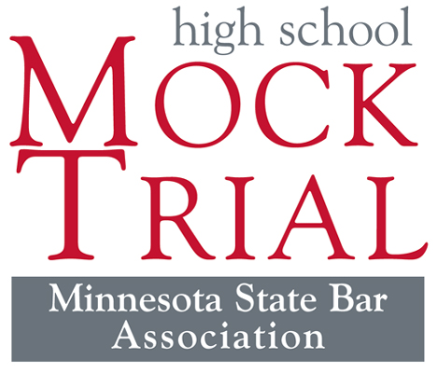
Interested in Law? Teamwork? Public Speaking? Acting?
Then come to the Mock Trial meeting.
Mock Trial, an exciting law-related education program sponsored by the MSBA, presents you with the unique opportunity to work with lawyers and judges who participate in the legal system daily.
The statewide competition begins the week of January 9, 2023, and concludes with 16 regional winners competing in March 2023 for the State Championship and a chance to represent Minnesota at the National High School Mock Trials Championship in May 2023 in Little Rock, Arkansas.
Please join us to learn more and register.
Practices will be ___________________________________ and competitions are held during the day for greater Minnesota and on Tuesday or Thursday evenings for teams in the Twin Cities metro area during the months of January and February.
FIRST MEETING
Date:
Time:
Location:

