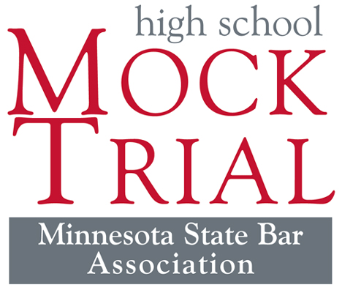
Interested in Law? Teamwork? Public Speaking? Acting?
Then come to the Mock Trial meeting.
Mock Trial is an exciting law-related education program, sponsored by the MSBA, presents you with the unique opportunity to work with lawyers and judges who participate in the legal system daily.
The first of five rounds of competition begins the week of January 9th, 2017 and concludes with 12 regional winners competing in St. Cloud March 3-4, 2017 for the State Championship and a chance to represent Minnesota at the National High School Mock Trials Championship May 11-14, 2017 in Hartford, CT.
Date:
Time:
Location:
Contact:
This year’s case will be released on October 19th.

